Networks Assignment 4

Group 21

Application 3

PART B Observations

PART-B: Started 2 other flows sharing the bottleneck while the first one is in progress and measured the throughput (in Kbps) of each flow. Plotted the throughput and evolution of the TCP congestion window for each of the flows at a steady-state. Reported is the maximum throughput observed for each of the flows

We have created a Dumbbell topology with two routers R1 and R2 connected by a (10 Mbps, 50 ms) wired link. Each of the routers is connected to 3 hosts i.e., H1 to H3 (i.e. senders) are connected to R1 and H4 to H6 (i.e. receivers) are connected to R2. The hosts are attached with (100 Mbps, 20ms) links. Both the routers use drop-tail queues with queue size set according to bandwidth-delay product. Senders (i.e. H1, H2 and H3) are attached with TCP Hybla, TCP Westwood+, and TCP YeAH-TCP agents, respectively.

We used NS3 3.28 flow monitor module to collect and store performance data from the simulation.

Attached below are the output graphs for the three congestion protocols that we have used, namely, TCP Hybla, TCP Westwood+ and TCP Yeah.

The observations were taken until there was no appreciable difference noted in the pattern of the output. Once the outputs had monotonised or fallen into a repetitive pattern, we stopped recording observations.

**Congestion Loss for Hybla:**

Tcp Hybla Flow 2 (100.101.2.1 -> 100.101.6.1)

Total Packet Lost: 12

Packet Lost due to buffer overflow: 0

Packet Lost due to Congestion: 12

Maximum throughput(in kbps): 839.715

Total Packets transmitted:1000000

Packets Successfully Transferred:999988

Percentage of packet loss (total):0.0012

Percentage of packet loss (due to buffer overflow):0

Percentage of packet loss (duee to congestion):0.0012

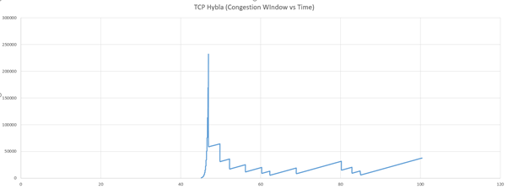

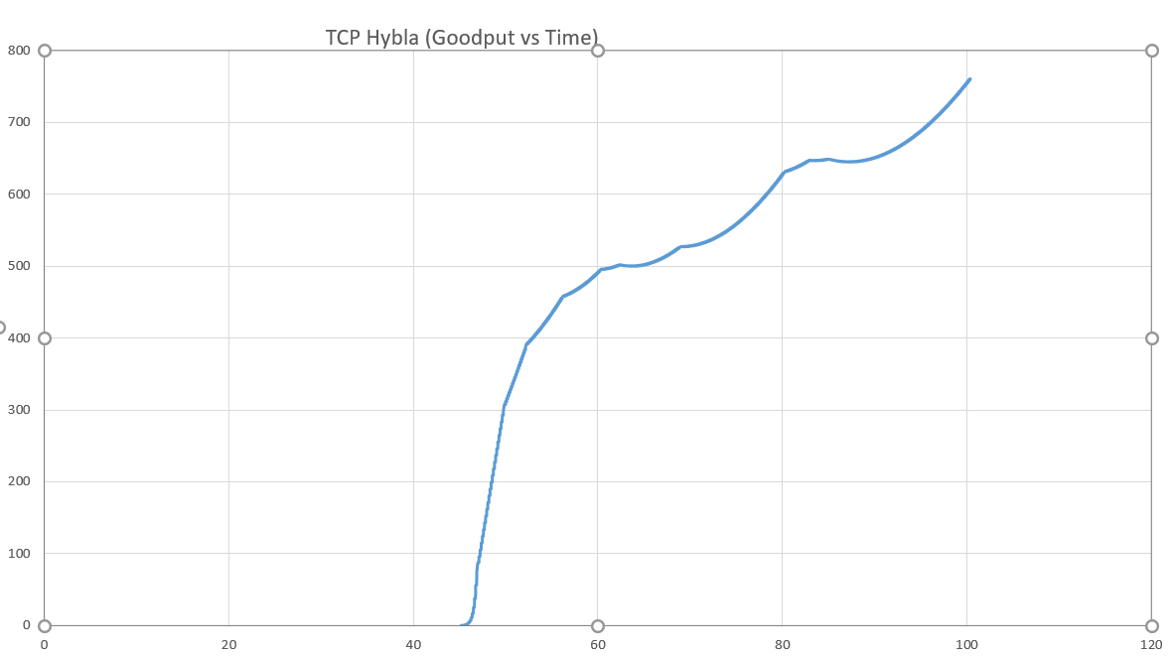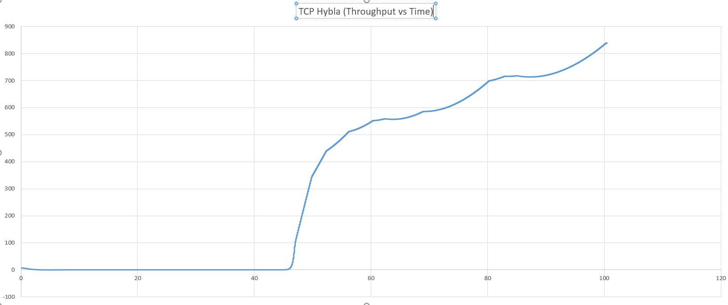

**Congestion Loss for Westwood+:**

Tcp Westwood+ Flow 3 (100.101.3.1 -> 100.101.7.1)

Total Packet Lost: 11

Packet Lost due to buffer overflow: 0

Packet Lost due to Congestion: 11

Maximum throughput(in kbps): 827.442

Total Packets transmitted:1000000

Packets Successfully Transferred:999989

Percentage of packet loss (total):0.0011

Percentage of packet loss (due to buffer overflow):0

Percentage of packet loss (duee to congestion):0.0011

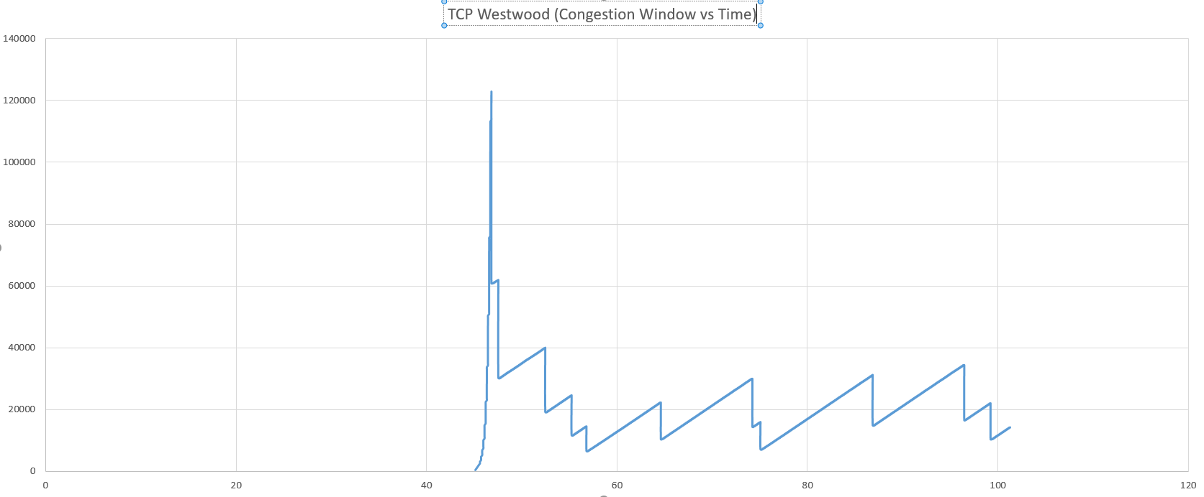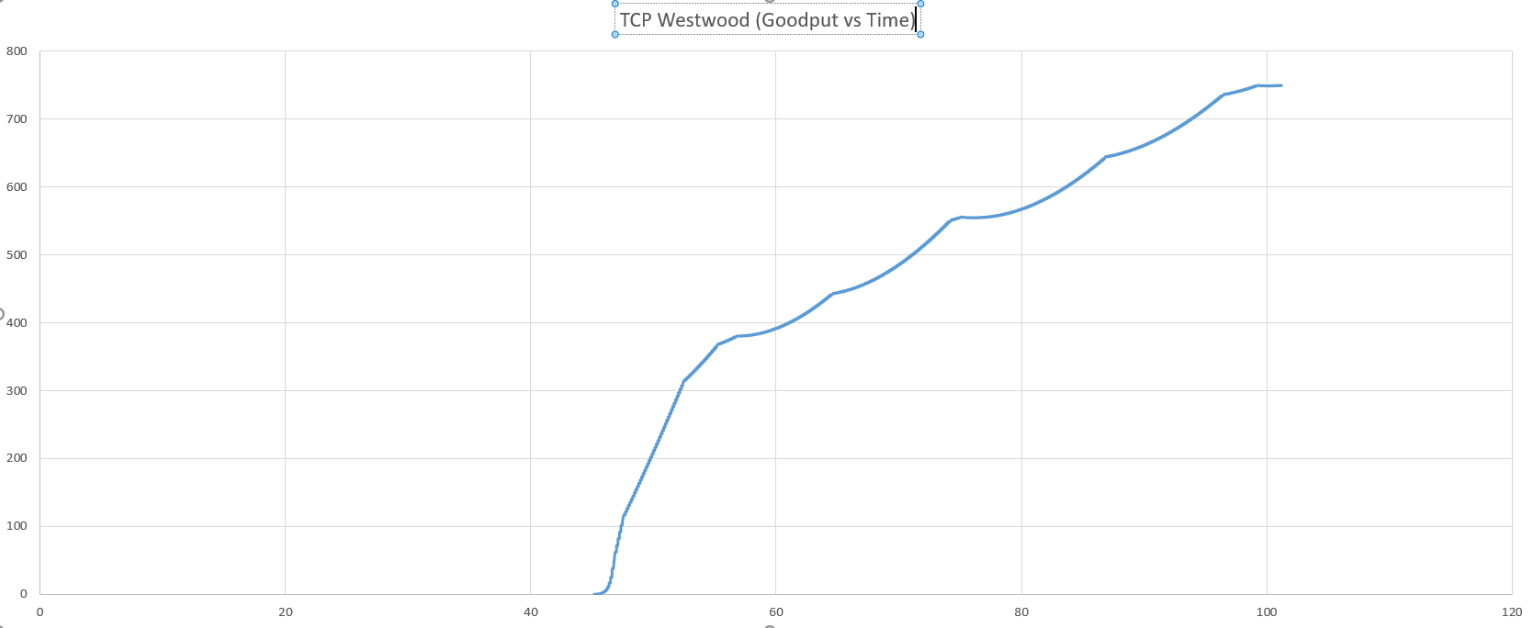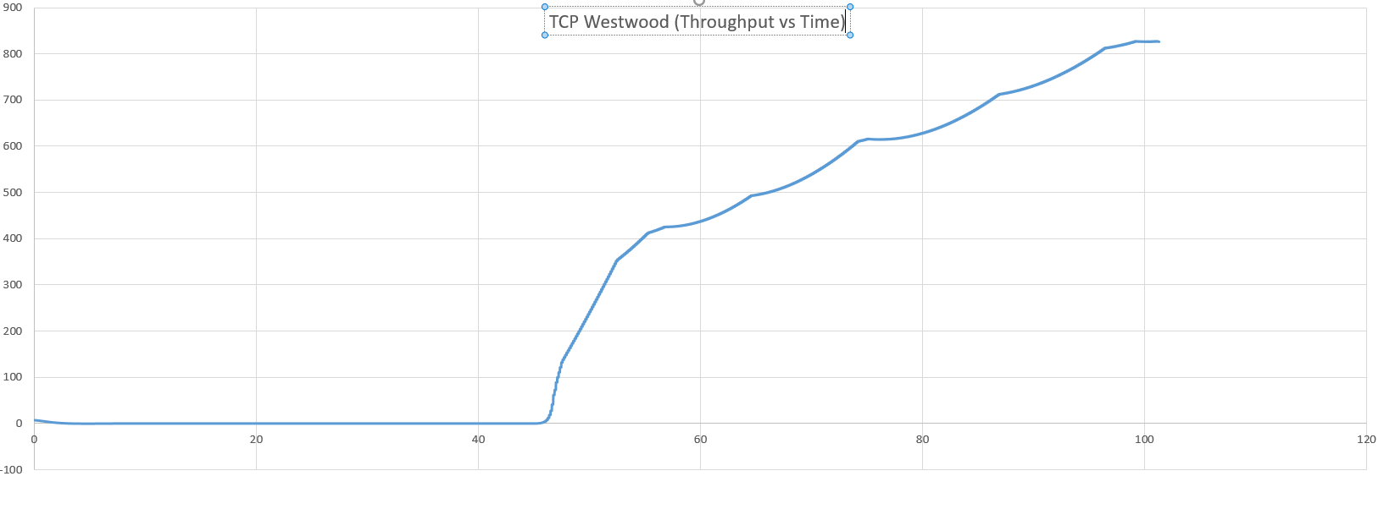

**Congestion Loss for Yeah:**

Tcp Yeah Flow 1 (100.101.1.1 -> 100.101.5.1)

Total Packet Lost: 20

Packet Lost due to buffer overflow: 0

Packet Lost due to Congestion: 20

Maximum throughput(in kbps): 4090.22

Total Packets transmitted:1000000

Packets Successfully Transferred:999980

Percentage of packet loss (total):0.002

Percentage of packet loss (due to buffer overflow):0

Percentage of packet loss (duee to congestion):0.002

